The POEM BOOKLET “garden of words”
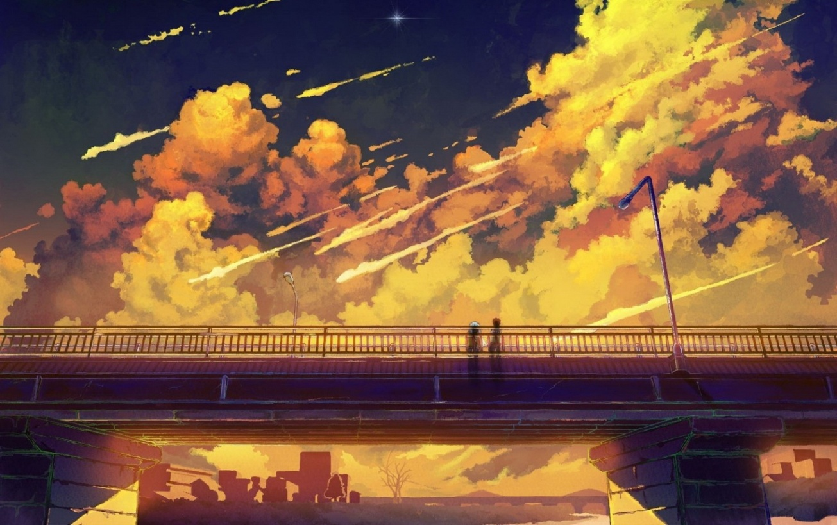
By ghita azaroual 2c
My Poem list:
- I am poem
- Opposite poem
- Look in the mirror poem
- Acrostic poem

I am poem
I am trustworthy and modest
I wonder about what makes a person honest
I hear the song of a humming bird
I see the most beautiful landscape
I want to draw again and forever
I am trustworthy and modest
I pretend to be quiet and shy
I feel looked down on by other people
I touch the fur of a white tiger
I worry about the current state of the world
I cry of frustration when things don’t go my way
I am trustworthy and modest
I understand that not everything is perfect
I say that being different is a good thing
I dream about a better future
I try to improve my work
I hope to be a respected and successful artist
I am trustworthy and modest

Opposite poem
I love to share what I love with my friends
I dislike uninteresting worthless conversation
I have a lot of things to do
I want more free time to do them
My friends say I am kind and sympathetic
My family says I am cold-hearted
One day I will become a respected artist
I will never be a boring person
My favorite foods are anything salty and savory
I’ll never eat sweet things
I feel sad when I can’t draw for I long time
I feel happy when I’m with my best friends
I feel safe when I’m alone in my room
I feel scared when I’m surrounded by people I don’t know
Look in the mirror poem
I look in the mirror and what do I see?
A modest, honest, sincere person looking back at me.
I’m really good at being myself, and drawing
And love to be with my friends like any other
I spend lots of time reading
And I can’t wait for the school year to be over
I could improve my social skills
And talking to people is hard for me,
But I know if I try, I’ll be the best I can be.

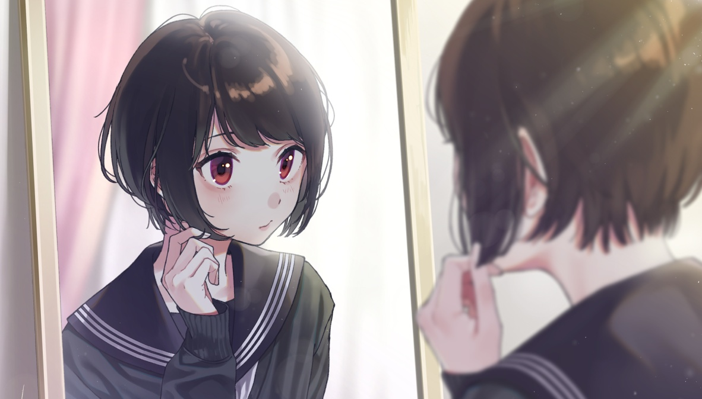
Acrostic poem
B ehind the door a new adventure awaits
E nigmatic as it may be, you can over come it
G et your team together and go away
I nventive strategy will save the day
N othing will stop us, exept this monster
A giant foe that we will conquer
D ead in our tracks we stop again
V icious trolls have joined their friend
E ven all their effort was not enough
N o they were weaker then we thought
T he sacred treasure lies ahead
U nlimited power until the end!
R eliable heroes, run faster !
E ND THIS TALE, it’s over !
The end

